**Alpha Omega News**

**May 2023**

**Everyone had a fun time at our May Initiation Meeting!**

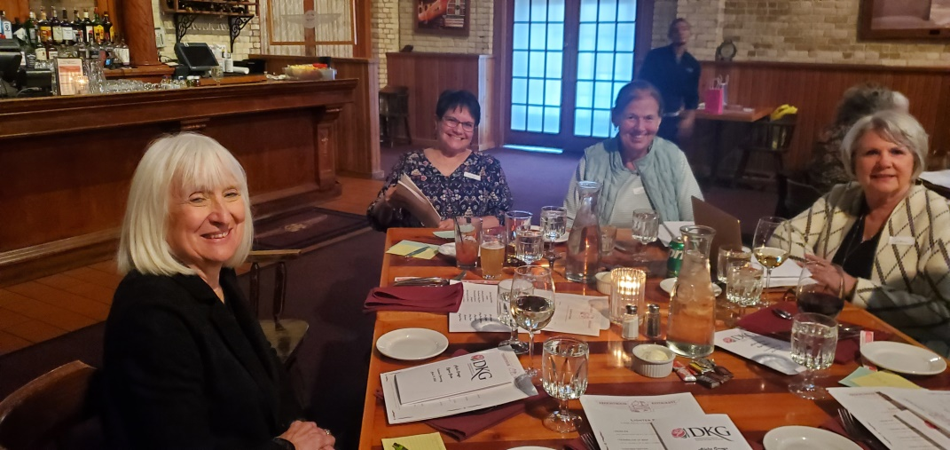

**Pam Griffith, Amy Hysel, Louise Sedevie-Lawrynk, Jan Marson**

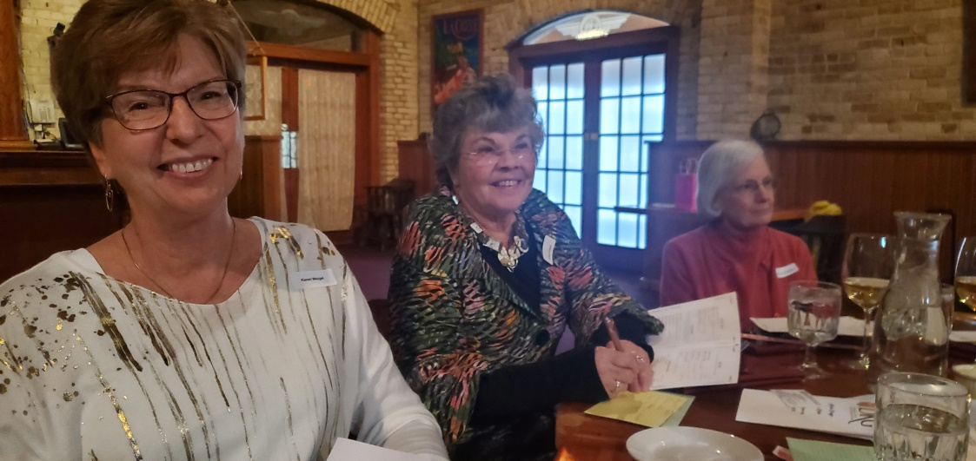

**Karen Weigel, Cyndy Schaper, Connie Albrechtson**

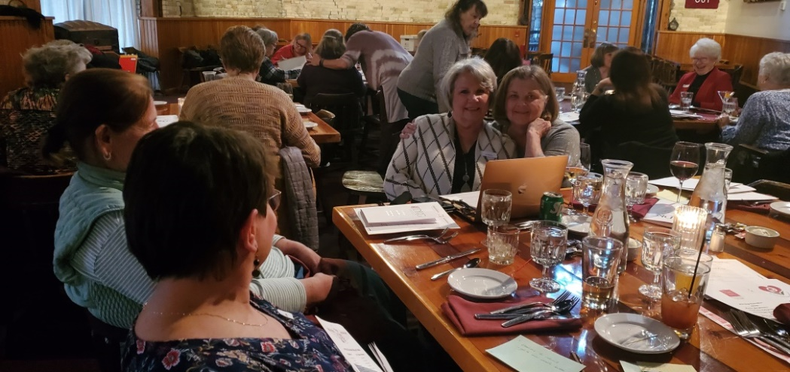

**Jan Marson, Roxanne Fox**

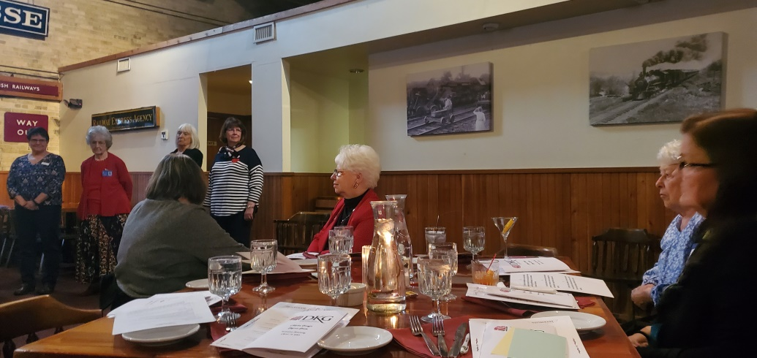

**Lois Holper, Marilyn Arndt, Mary Wetterling and Sally Emerson at table.**

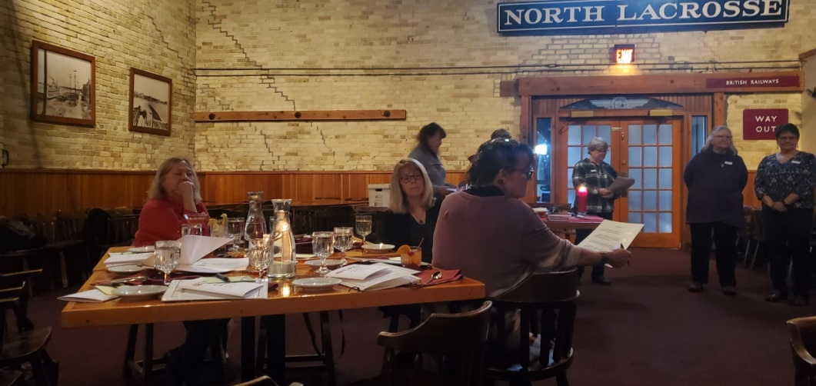

**Carol Nelson-Britten, Kathy Fuss, Joann Zigler at table**

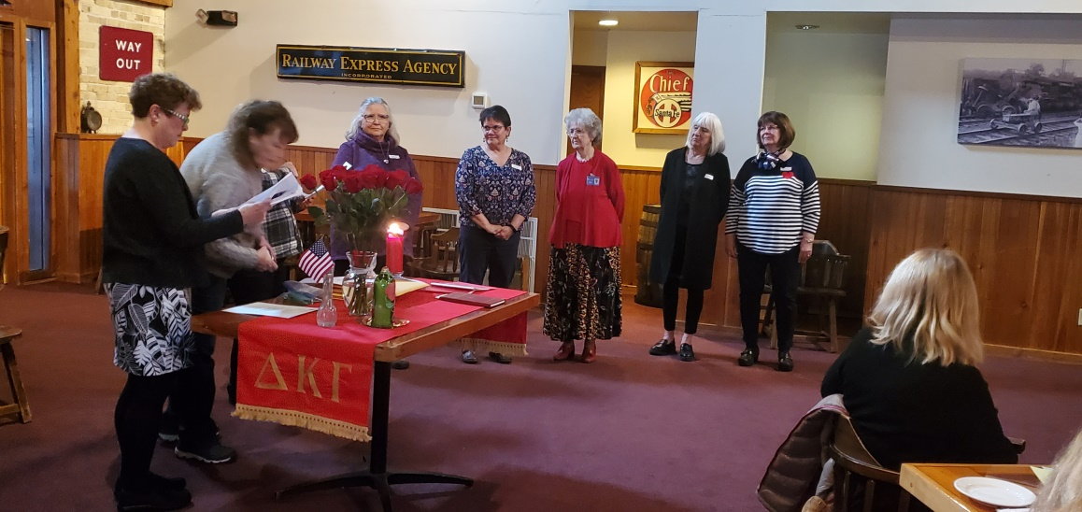

**Terri Daley-Mack and Barb Albrechtson with our newest members Merry Kocar, Amy Hysel, Mary Ann Gschwind, Pam Griffith and reinstated Margaret Wood.**



**May 4th - 6th**

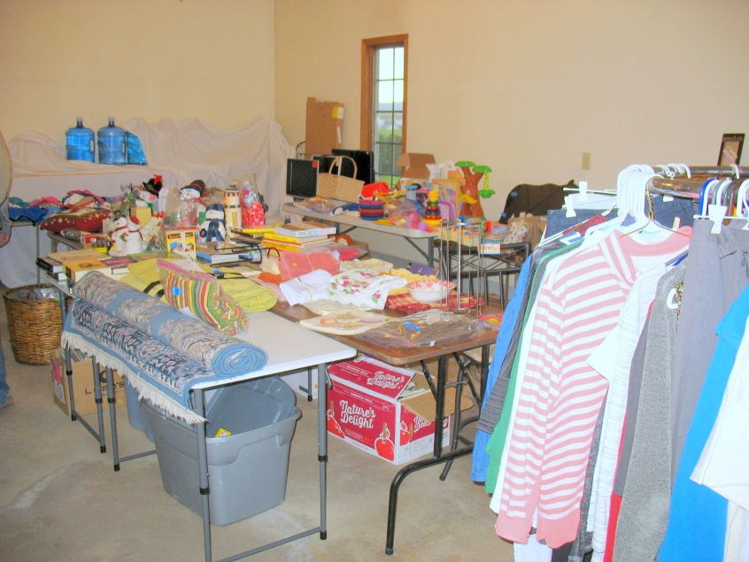

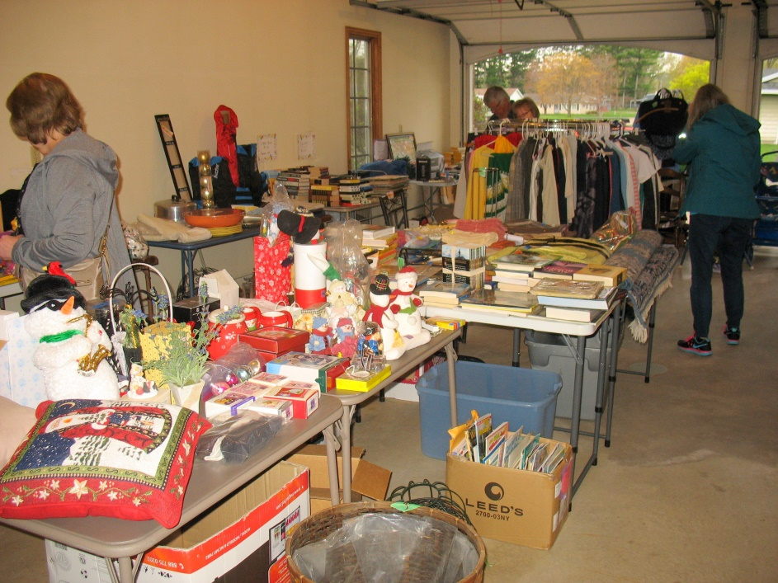

**Set up on Thursday with a great variety of items for sale.**

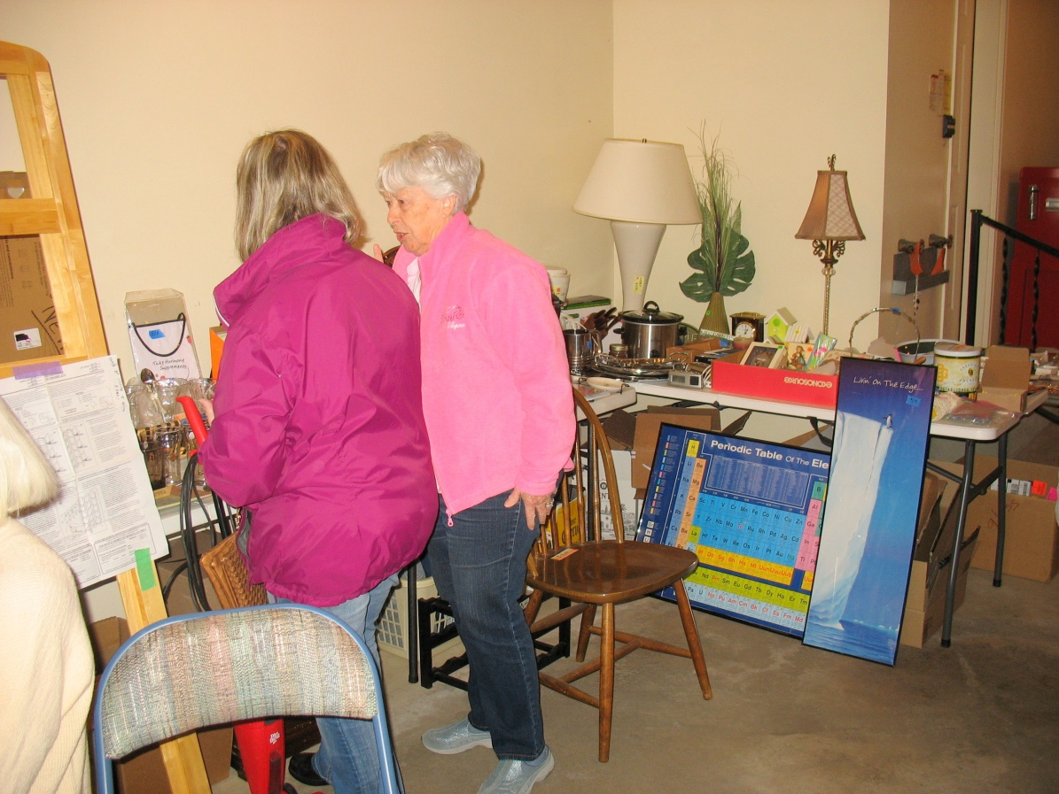

**Mary Wetterling making a sale.**

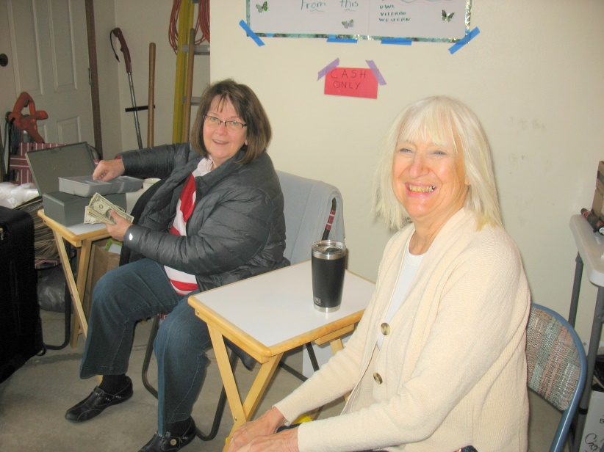

**Margaret Wood and Pam Griffith**

**Help with taking down the rummage sale!**

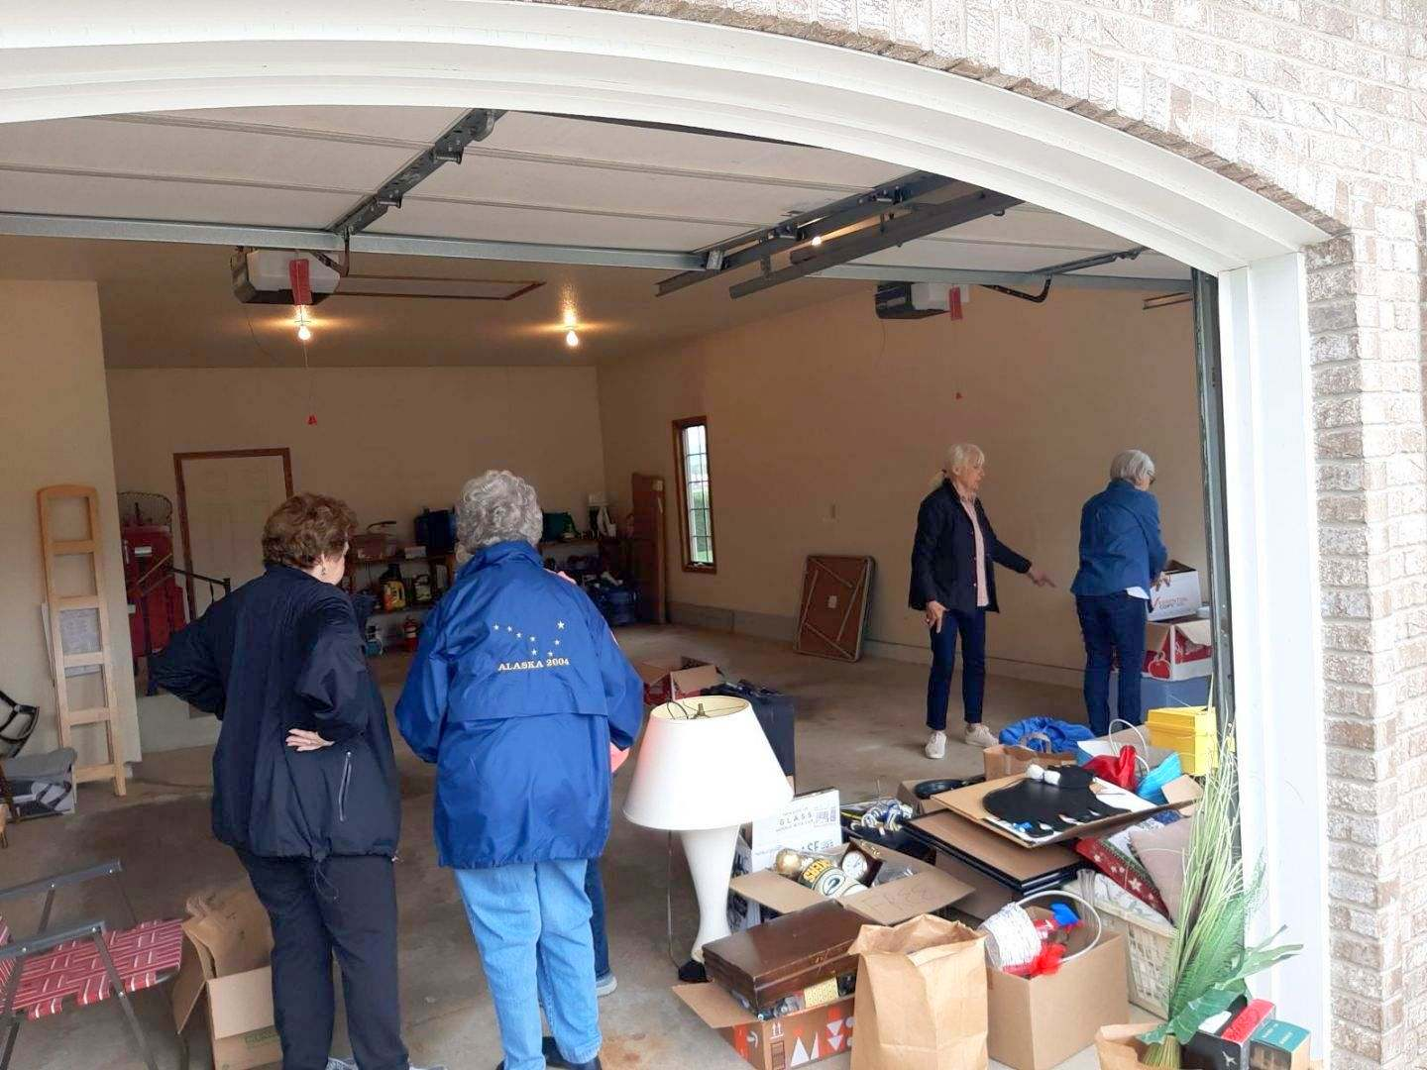

**Carol Egge, Mary Ann Gschwind, Pam Griffith, Mary Wetterling**



**Our Next Meeting Will Be June 26th**

**Joint Meeting with Theta Chapter**

**Kindness Bash**

**Dinner at Freight House**

**107 Vine St. – La Crosse**

**4:30 Social**

**5:00 Presentation by Tita Yutuc**

**C.E.O. of the Family & Children’s Center**

**6:00 Dinner**

**June’s Charity is**

**Family & Children’s Center**

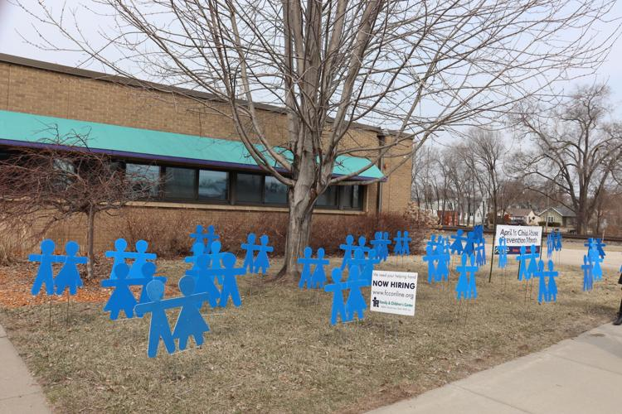



This year we will be mentoring our new members so that they will enjoy being a member of Alpha Omega! We want them to enjoy the fellowship of our group.

This year’s new member is: Merry Kocar and soon to be Sally Emerson

All members are invited to send them a note of appreciation that they are a part of our organization.



Thank you DKG group! I really appreciated & enjoyed the lovely bouquet. The Chamber Chorale concerts in honor of my retirement were super lovely on 3/4&5! They are THE best of the best. Thank you for sending the bouquet which added to my celebration very beautifully. Take care, stay well & look forward to spring.

Gratefully,

Mary Ann Gschwind

Dear DKG Sisters,



Thank you for your thoughtfulness and the beautiful rose arrangement following my knee replacement surgery. It was also nice to visit with a fellow DKG Sister,

Love,

Jean Wetzsteon

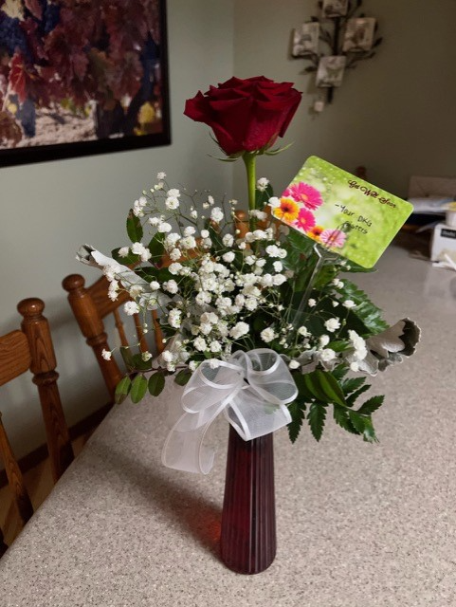

Dear DKG Sisters,

Thank you so much for the beautiful rose for my robotic-assisted total knee replacement surgery which I had on March 15.  It was delivered to me the day before my surgery, and it gave me a smile and encouragement for the surgery.  I am doing quite well, and will be at the 3-week mark on Wednesday of this week.  There has been a lot of pain, as I had expected, but every day is a little bit better.  I have had wonderful care and am feeling very optimistic.  I can walk with a cane already!  If any of you are considering knee replacement surgery and would like to know more about it from someone who has had the surgery, I would be happy to share my experience as so many kind people did for me to help me make an informed decision.



DKG Kentucky State Organization

Thank you so very much for your generous donation to assist our KY DKG sisters!



Dear DKG Sisters,

Thank you so much for the beautiful flowers.  They really brightened my day.  I have also appreciated all of your cards and support.

Here's an update. I had a scan last week and it's showing that the cancer is growing.  I'm starting a new treatment plan in a couple of weeks.  I'll still have one infusion but will be on an oral plan.  I guess this plan has had some good results.   The good news is I feel good with no pain or symptoms.

Please keep those prayers and good thoughts coming.  I'm positive they are helping me feel good.

Thank you again for your support.

Mary



Thank you Sisters,

My surgery went very well. As I sit here relaxing, I’m looking at my beautiful flowers from my DKG sisters.  My heart is happy.

Jan



* Rox has already started the photo directory. We need to add some photos for those who were not at the meeting.
* Thank you to those who have already sent some ideas for kindness sayings that we will be presenting our Theta Chapter guests. If you come across any cute kindness sayings please email them to me at [tzigane2@hotmail.com](mailto:tzigane2@hotmail.com)

Connie Albrechtson, Carol Egge, Pam Griffith and I will work on putting them together at the end of June before our meeting.

* I will collate program ideas and “How I can make DKG Better for me” for everyone to see before our June meeting. Some GREAT IDEAS!
* At our June meeting we will schedule committee meetings for over the summer especially Program, Service/Charity, and Fundraising. Be thinking of ways that we can perform service activities in our community.
* We need members to sign up for the nomination committee for 2024-2026. We will need to be looking for a new Treasurer, Corresponding Secretary, Recording secretary, Vice-President. Would anyone be interested in filling in for Kathy Dressler this coming year as Vice-President? Then in 2024-2025 I would co-share being President with you. Then you can take over the Presidency for 2025-2026 and if you need help, I’ll be there for any assistance.

**State Convention In Pewaukee May 6th**

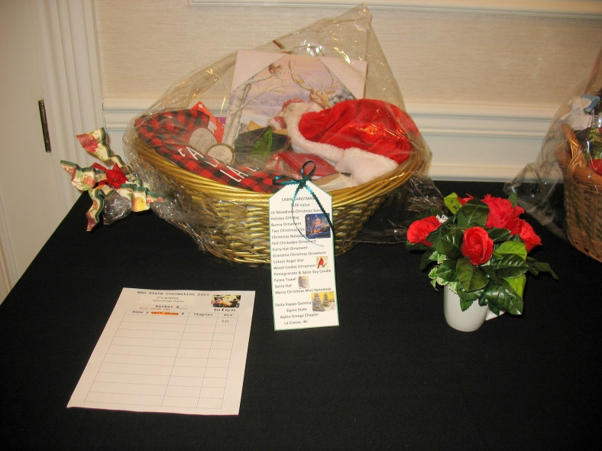

The beautiful basket “Cabin Christmas” put together by Carol Nelson-Britten and Mary Swingle up for auction.

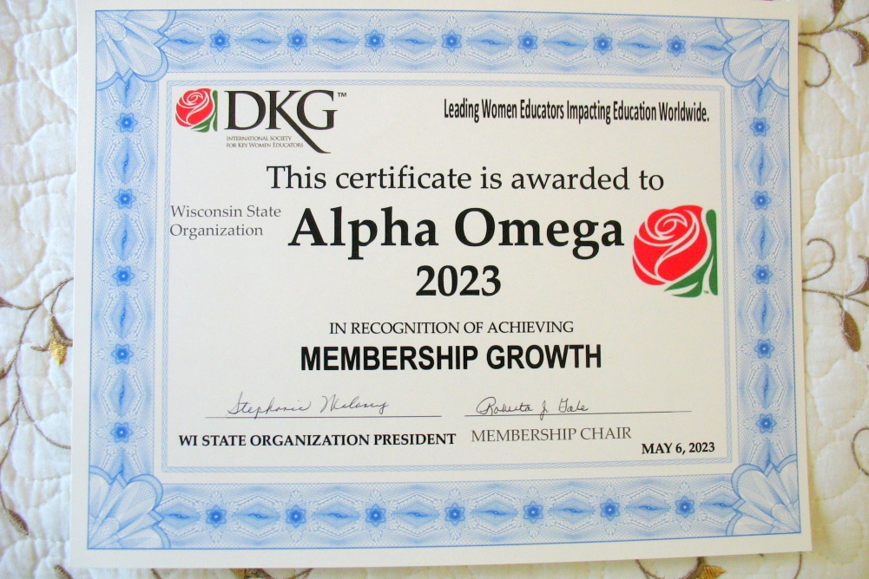

**The Certificate that Alpha Omega was awarded for Membership Growth at the convention.**



***Remember YOU are the center of the reason for DKG!***

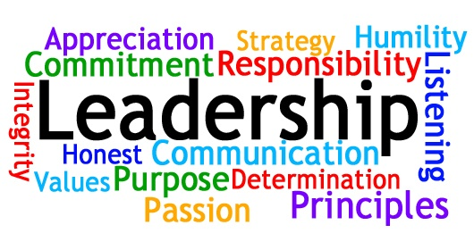

**Officers for 2022-2024**

President – Barb Albrechtson

Vice-President – Kathy Dressler

Treasurer – Priscilla Thibodeau

Corresponding Secretary – Stephanie Baumgartner

Recording Secretary – Jan Marson



**Committees for 2022-2024**

**Communication Representative/Historian** – Roxanne Fox

**Membership** – Stephanie Baumgartner, Terri Daley-Mack,

Kathy Dressler

**Program** – Jackie Meyer, Cyndy Schaper, Marilyn Arndt, Lois Holper, Jan Marson, Shirley Ruoff, Carol Egge, Mary Wetterling

**Scholarship** – Priscilla Thibodeau

**Service/Charity Committee** – Deb Keller, Priscilla Thibodeau,

Lois Holper, Marilyn Arndt, Mary Wetterling

**Fundraising Committee** – Joann Zigler, Mary Wetterling

**By-Laws Committee** – Barb Albrechtson, Kathy Dressler,

Carol Nelson-Britten

**Save the Date!**

**International Conference will be in Detroit, Michigan July 11-15**



**Save your books for the Free Library**

**in memory of Claire Jandt**

**At Jandt-Fredrickson Funeral Home and Crematory**

You can

bring your books to the June meeting