**La Crosse Area Retired Educators’ Association (LAREA)**

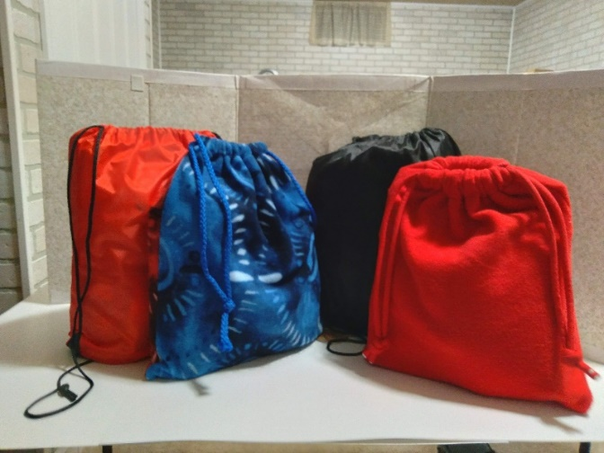

**What Are We Care Bags?**

**Our Description of We Care Bags…**

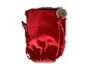LAREA members have been putting together “We Care Bags” for elementary, middle, and high school children for nine years now. They are given to children who are experiencing difficult times in their lives such as, no place to call home, in foster care, illness in the family, loss of a parent, and so on…

These bags include comfort items (stuffed animals, stress relievers, blankets, positive messages, etc.), enjoyment items (drawing pads/notebooks, pens/crayons, “I Spy” cards, card games, etc.), and health items (comb/brush, toothbrush & paste, soap & washcloth, shampoo, etc.). The items are selected to help them take care of their needs, feel better about themselves, and brighten their day.

A total of 300 We Care Bags are filled by LAREA members’ and community supporters’ donations. They are distributed to 36 schools in our region. When school counselors/social workers find a child is going through tough times, they give them a We Care Bag to take with them wherever they are living at the time. Our goal is to let these children know that there is someone out there that cares about them.

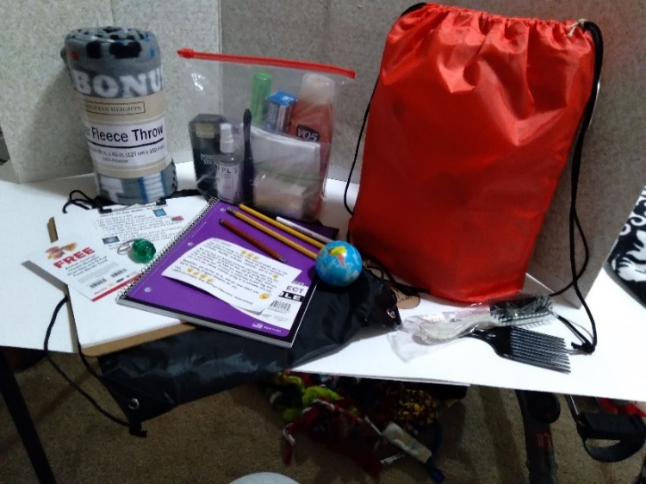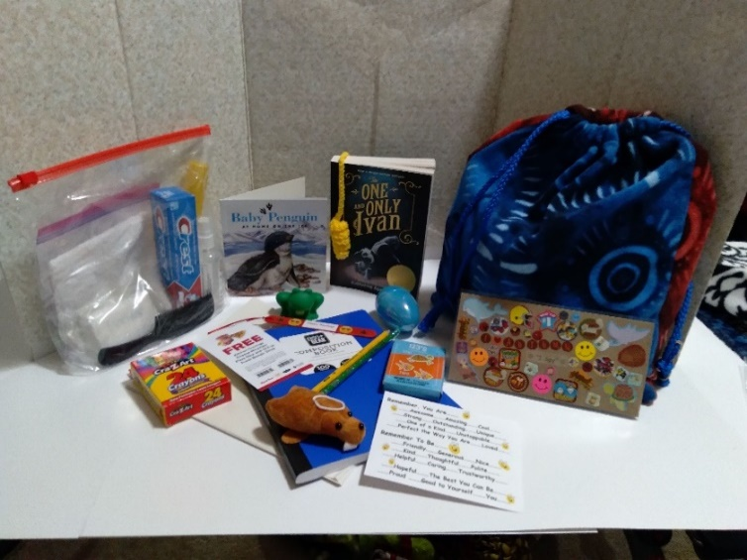

Elementary Bag Content Middle/High Bag Content