**Alpha Omega News**

**February 2021**

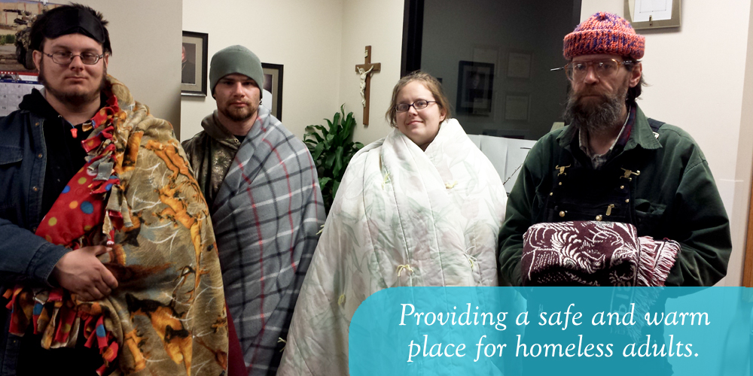

**Message from Michele about fundraiser for Warming Center**

DKG Sisters,

Thank you for your generous donations (totaling $350.00) to the La Crosse Warming Center.  As you may have heard, Catholic Charities is currently in the process of relocating Warming Center guests from the previous site downtown to a hotel on the north side of La Crosse.  Given this, I have been in contact with the site coordinator (Morgan Pederson) who is going to provide me with a list of significant needs once they get established at the new location.

Thank you for your support of the Warming Center and the La Crosse community!

Michele

**Next Fundraiser**

Our next fundraiser will be for the Place of Grace (Catholic Charities).

Please send donations written out to “**Place of Grace**” to

Connie Albrechtson

3324 Meadow Lane

La Crosse, WI 54601

Between April 5th through April 12th 2021

Priscilla Thibodeau will hand deliver the checks to the accountant.

**Save your books for the Free Library in memory of Claire Jandt**

**At Jandt-Fredrickson Funeral Home and Crematory**

You can drop your books off at

Carol Egge

3647 Bentwood Place

La Crosse, Wi 54601

608-788-2173

Jackie Meyer will add our donated books when needed to the library.

**Membership Dues are $72.00**

*Connie called to let me know that the secretary minutes needed to be changed from $70 to $72*

Membership dues are due by April 30th.

Checks should be made out to DKG and sent to

Connie Albrechtson

3324 Meadow Lane

La Crosse, WI 54601

**Reminder**

Update your personal information on the international website.

https://www.dkg.org/

Sign in using your membership number for username.

If you do not have a password, you will need to create one.

Click on MYDKG and go to My Account to update information.

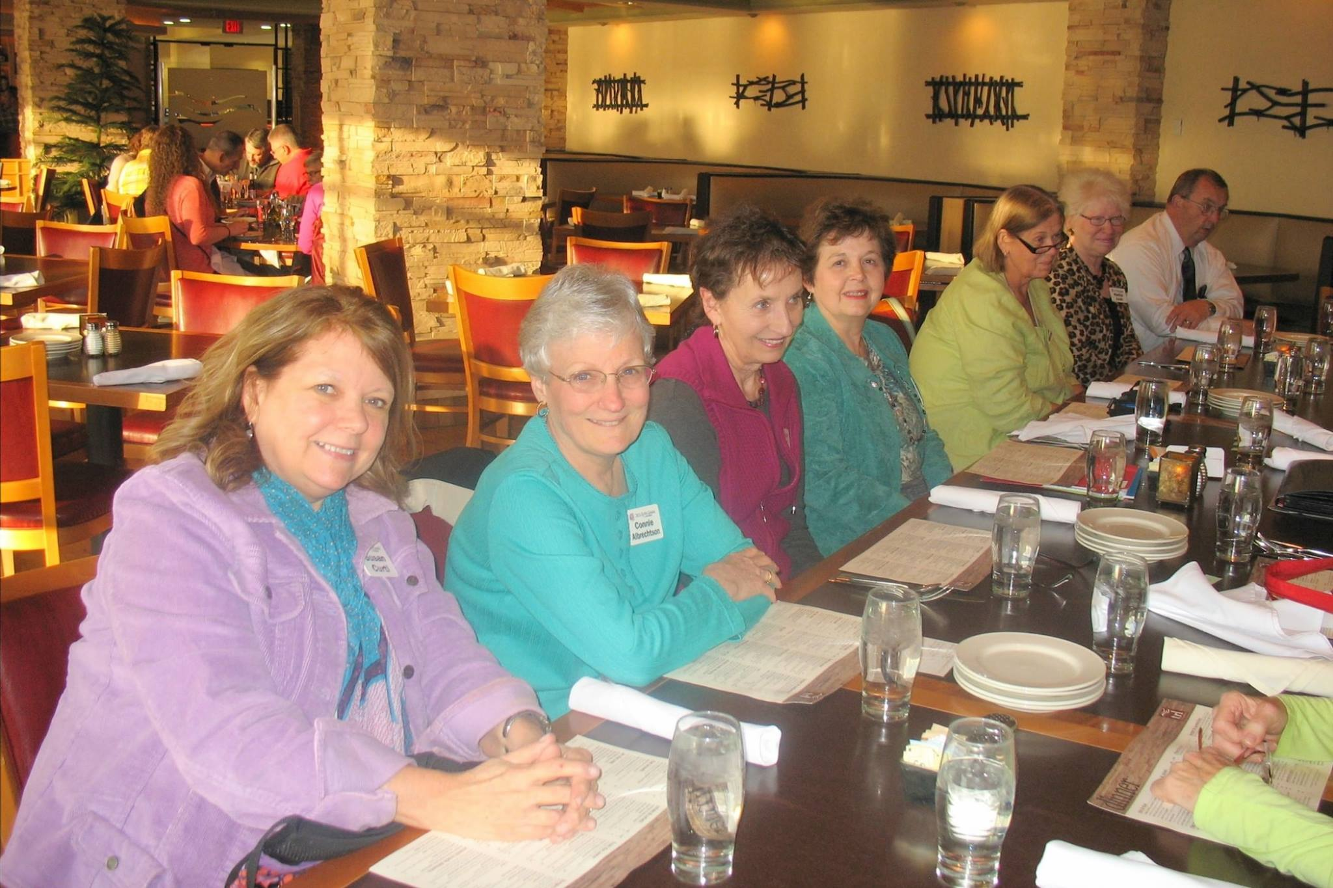

**Thank You!**

Roxanne Fox for creating a Face Book page for our chapter

**Alpha Omega Chapter – DKG – La Crosse, WI**

This is a great place for us to stay connected.

Let’s share each other passion!

Looking forward to seeing all your comments.

**WSO State Convention**

Be looking for information in March

The virtual event will be held on May 1st from 9 AM to 2PM

Registration fee will be $25

We are looking forward to having Sarah Daman, author and woman coppersmith (she was featured in the last issue of Our Wisconsin magazine); Dr. Brogden, DKG First Vice President and Dean of Education at Laruentian University, a tri-cultural university in Northern Ontario; a panel reflecting on teaching during the COVID era; a quilter; a teacher becoming a school board member; literary contest winners; awards announcements; and installation of the 2021-2023 WSO Officers

**Upcoming International Women’s Day Event**

**March 8th**

The international Women’s Day Committee invites members of the La Crosse community and beyond to a virtual celebration of International Women’s Day on Monday,

March 8 from 7 p.m to 8 p.m.

The celebration will consist of a panel discussion with a special emphasis on gender equity around the world. Panelists will include Barbara Oehninger from Switzerland, Marta Martinex from Uruguay, Ayesha Patnaik from India, and Chero Chuma from Kenya.

This year’s celebration will take place via ZOOM and is free to the public. Prior registration is suggested; visit the following website to register:

https://www.uwlax.edu/calendar/?e=23736.

For more information, contact: Erica Koonmen, AAUW, aauwlacrosse@hotmail.com

For more details about the history and traditions of the celebration around the globe, visit internationalwomensday.com

**Our Next ZOOM meeting**

**Monday, April 13th**

Bring Your Chair Theme

Chair Yoga Demonstration

More information coming in March.

Meeting will start at 5:00 p.m. followed by Chair Yoga at 5:30 p.m.

**Passions shared**

Carol Egge – Scrapbooking, Books on Shutterfly, Travel and Reading

Lois Holper – Travel the World and Reading

Connie Albrechtson – Animals, Reading, Doing Word and Number Puzzles

Jan Marson – Growing as a Human Being – Reading – Learning

Barb Albrechtson – Dance

Go on our new Face Book page and Share Your Passion

**Presentation by Jamie Dahl**

Jan Marson did an excellent job summarizing Jamie’s presentation in her secretary minutes for the DKG Business Meeting February 11, 2021 ZOOM meeting.

Jamie’s book I Have Two Words For You can be purchased on Amazon, Barnes and Noble and her website. If you purchase the book from her website, she will personally sign it.

https://thedahiadiaries.com/



**Committees for 2020-2022**

Communication Representative – Roxanne Fox

Membership – Stephanie Subjek, Terri Daley-Mack

Program – Jackie Meyer, Louise Sedvie-Lawrynk, Cyndy Schaper

Scholarship – Connie Albrechtson

Service/Charity Committee – Deb Keller, Priscilla Thibodeau

**We are still looking for volunteers for being Vice-President**