**Alpha Omega News**

**September 2022**



**October 26th 2022**

**Fall Theme Meeting**

**Fork & Fable Crafthouse formerly the Arterial**

**1003 16th Street, La Crosse**

**4:00 Social**

**4:30 Meeting**

**5:00 Presentation**

**La Crosse Public Education Foundation – Nell Saunders**

**5:30 Dinner**

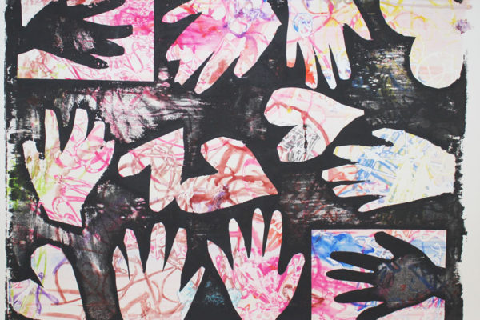

**October’s Charity is**

**Random Acts of Kindness through the La Crosse Public Education Foundation**

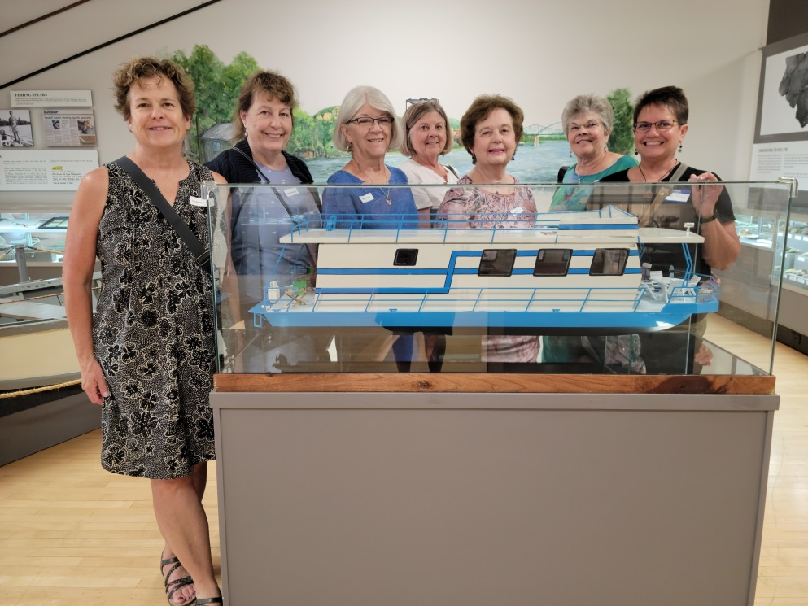

**We had 21 members/guests who enjoyed breakfast at the Charmant and had fun on the guided Trolley Tour of La Crosse. Seven of us enjoy the tour at the Heritage Center. Here we are with the replica of Mary Wetterling’s houseboat.**

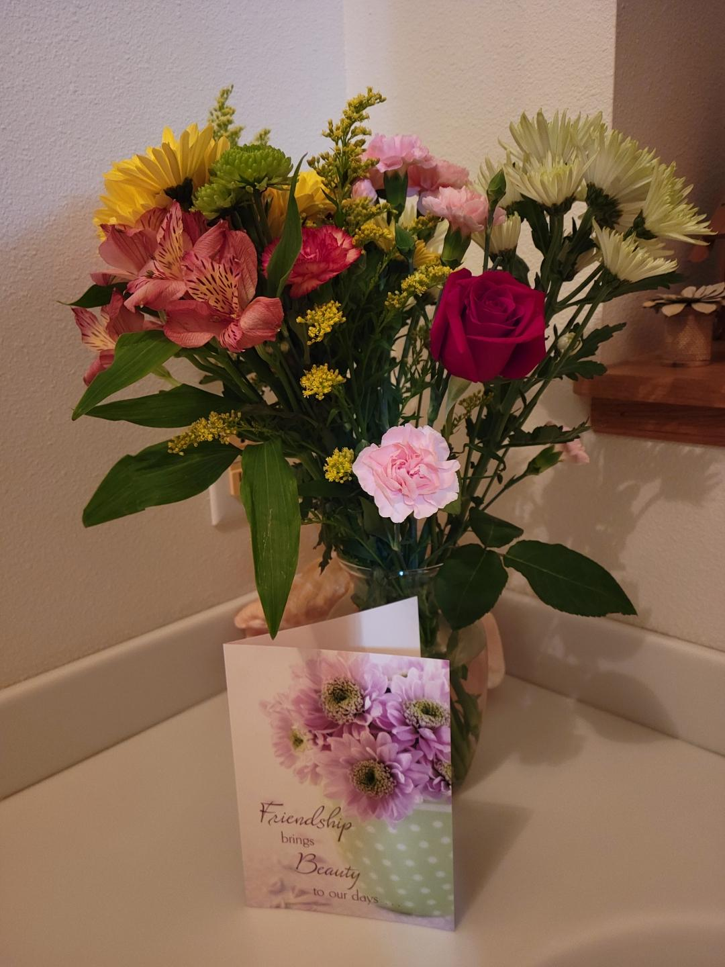

**Thank you DKG Sisters for the Beautiful Bouquet of Birthday Flowers!**

**Barb**

**Officers for 2022-2024**

President – Barb Albrechtson

Vice-President – Kathy Dressler

Treasurer – Priscilla Thibodeau

Corresponding Secretary – Stephanie Baumgartner

Recording Secretary – Jan Marson

**Committees for 2022-2024**

**Communication Representative** – Roxanne Fox

**Membership** – Stephanie Baumgartner, Terri Daley-Mack,

Kathy Dressler

**Program** – Jackie Meyer, Cyndy Schaper, Marilyn Arndt, Lois Holper, Jan Marson, Shirley Ruoff, Carol Egge, Mary Wetterling

**Scholarship** – Priscilla Thibodeau

**Service/Charity Committee** – Deb Keller, Priscilla Thibodeau,

Lois Holper, Marilyn Arndt, Mary Wetterling

**Fundraising Committee** – Joann Zigler, Mary Wetterling

**By-Laws Committee** – Barb Albrechtson, Kathy Dressler,

Carol Nelson-Britten

**Just a Reminder**

**Mentoring Our New Members**

This year we will be mentoring our new members so that they will enjoy being a member of Alpha Omega! We want them to enjoy the fellowship of our group.

This year’s new members are: Cathy Fuchs, Kathy Fuss, Pam Griffith and Shirley Ruoff

All members are invited to send them a note of appreciation that they are a part of our organization.



**We have three new member!**

**Margaret Wood**

**Amy Hysel**

**Mary Ann Gschwind**

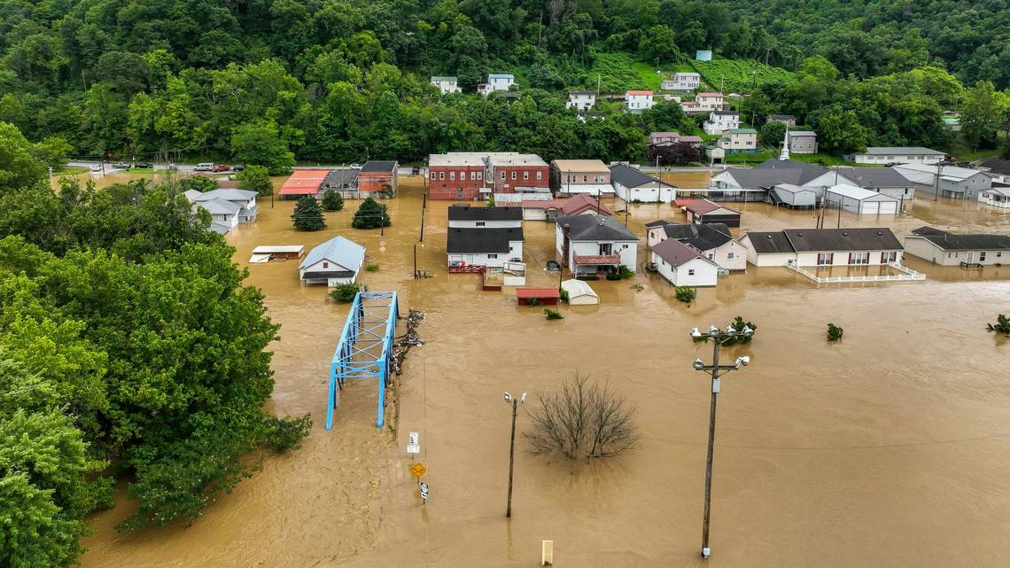

**Let’s Show Some Sisterly Love**

**From Roberta Gale, Membership Chair for WSO**

**One of the positives of attending Internation Convention is meeting people from around the world. One of my sessions was presented by Kentucky State President Bonnia Cook Fouts. She mentioned the devastating floods in Kentucky. When I returned, I contacted her and inquired about losses incurred by our DKG Sisters. One person's home is a total loss. Another lost an aunt and uncle. Kentucky Sisters are "adopting" an elementary school that was severely damaged. The library is a total loss. SO, Sister, can you save a dollar to send to support our Sisters in need.**

**I think it would be a wonderful idea if we all could chip in $1.00 each and send a check from Alpha Omega for our Sisters in Kentucky. If you would like to participate please bring a dollar to our next meeting.**

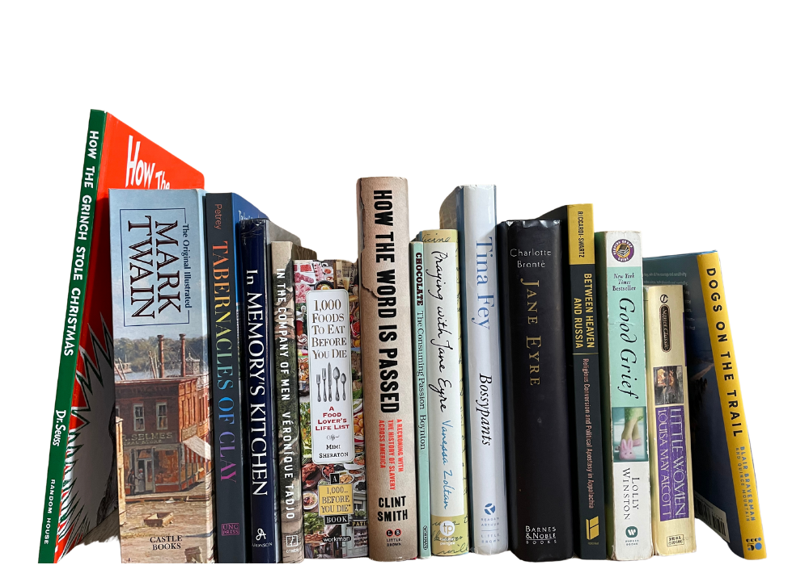

**Save your books for the Free Library in memory of Claire Jandt**

**At Jandt-Fredrickson Funeral Home and Crematory**

You can drop your books off at

Carol Egge

3647 Bentwood Place

La Crosse, WI 54601

608-788-2173

or bring them to the next meeting