**Alpha Omega News**

**May 2024**

**Everyone had a fun time at our May Initiation Meeting!** 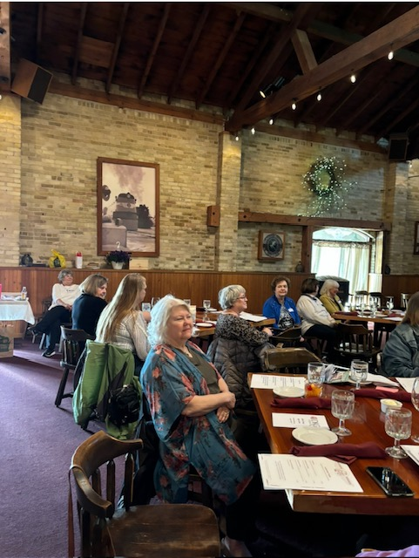

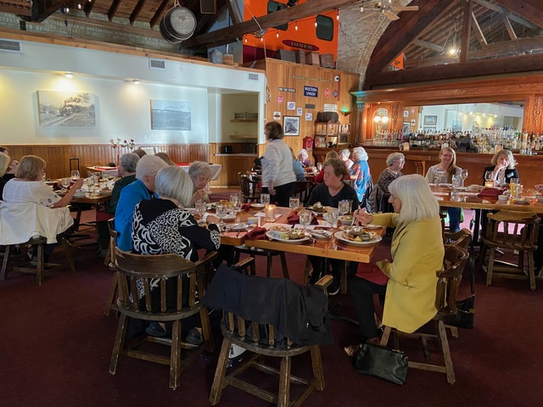

**Initiation of New Members**

**Jackie Meyer, Terri Daley-Mack, Barb Albrechtson, Sally Emerson & Mary Clark**

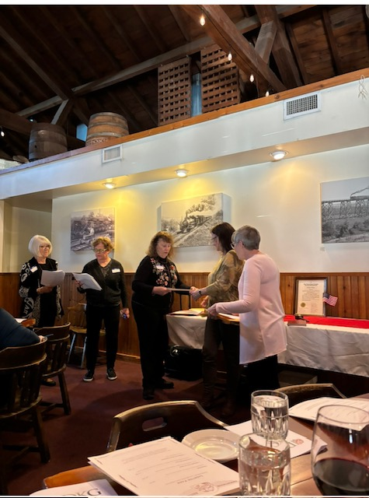

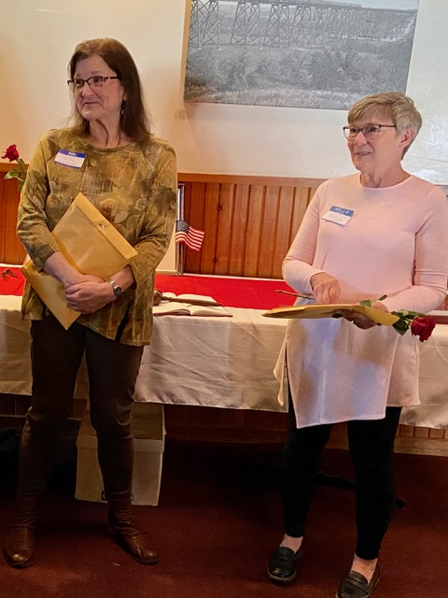

**Sally Emerson & Mary Clark**

**Our newest members**

**Initiation of New Officers**

**Roxanne Fox, Corresponding Secretary**

**Kathy Fuss, Recording Secretary**

**Barb Albrechtson, President**

**Margaret Wood presiding over ceremony**

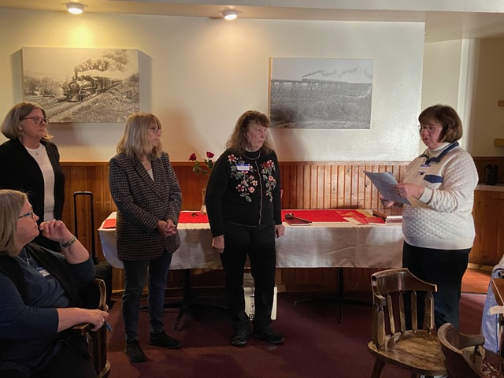

**Joann Zigler, Vice President**

**Lois Holper, Treasurer**

**Will be initiated at our first meeting for 2024-2025**

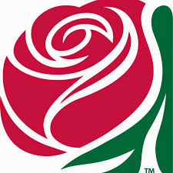

***Remember YOU are the center of the reason for DKG!***

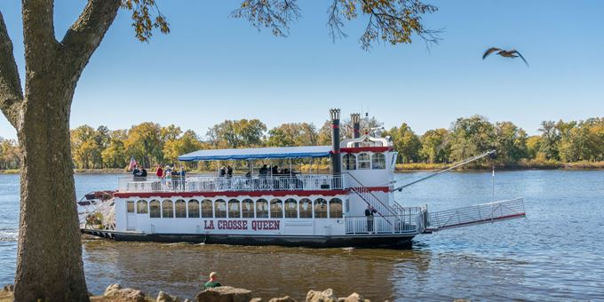

**Our Next Meeting Will Be June 12th**

**Joint Meeting with Alpha Upsilon Chapter**

**1:30 Cruise on the La Crosse Queen**

**Followed by lunch at Four Sisters around 3:30**

**Cost is Adult $19.95 and for Seniors $18.95**

**Advance reservations are required. Please order your ticket in advance at: the La Crosse Queen cruising site.**

[**https://lacrossequeen.com**](https://lacrossequeen.com)

**We will meet in the car park for the La Crosse Queens at 1:10.**

**Hope we can have a good representation from our chapter**

**If you do not want to do the boat tour possibly you could meet us for camaraderie at Four Sisters.**

**Please let Barb Albrechtson know that you can attend “Yes or No” by June 7th.**



This year we will be mentoring our new members so that they will enjoy being a member of Alpha Omega! We want them to enjoy the fellowship of our group.

This year’s new member are Sally Emerson and Mary Clark

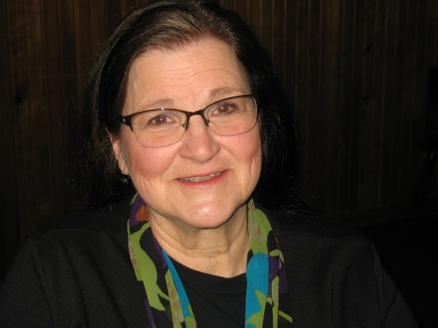 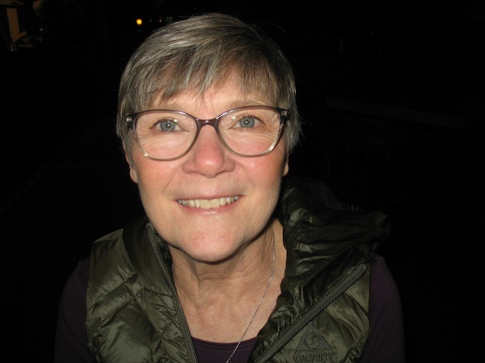

All members are invited to send them a note of appreciation that they are a part of our organization.

Sally Emerson: 612 Division St. Stoddard, WI 54658

Mary Clark: 317 21st St., La Crosse, WI 54601



Happiness is when what you think,

what you say,

and what you do are in harmony.”

Mahatma Gandhi

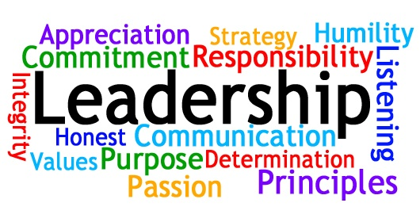

**Committees for 2022-2024**

**Communication/Marketing**

Rox Fox

**Membership**

Terri Daley-Mack,

**Program Committee**

Cyndy Schaper, Sally Emerson, Margaret Wood, Marilyn Arndt, Lois Holper

**Scholarship**

Priscilla Thibodeau, Pam Griffith, Terri Daley-Mack, Cyndy Schaper

**Service/Charity**

Terri Daley-Mack, Mary Clark, Cyndy Schaper, Deb Keller, Karen Weigel, Carol Egge, Lois Holper, Marilyn Arndt

**Fundraising**

Merry Kocar

**By-Laws/Rules**

Rox Fox, Cyndy Schaper, Mary Swingle, Carol Nelson-Britten

**Finance Committee**

Jan Marson, Connie Albrechtson, Michele Cook

**Nominations –**

**Everyone needs to sign up for a committee. If you were not at the meeting please let me know which committee you would like to sign up for.**

**Right now the committees that need members are**

**NOMINATIONS, MEMBERSHIP, FUNDRAISING,**

**Members can sign up for more than one committee but you need to sign up for one of the committee that needs members first.**

**Please consider the Nomination Committee. This responsibility should not fall on only the President. Our membership should help with finding members to fill our leadership roles to keep Alpha Omega a growing community.**



**Officers for 2022-2024**

President – Barb Albrechtson

Vice-President – Joann Zigler

Treasurer – Lois Holper

Corresponding Secretary – Roxanne Fox

Recording Secretary – Kathy Fuss

**We received the Membership Growth Award again this year for gaining members at the May Conference.**

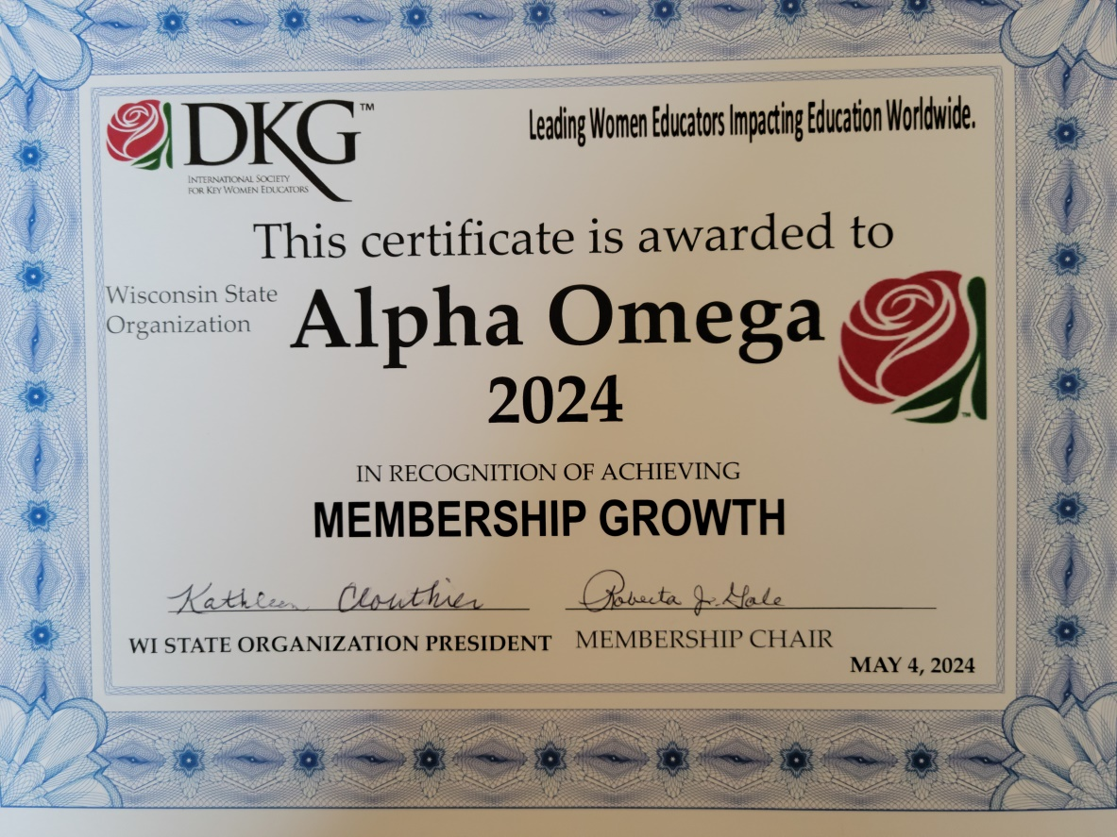



* **Carol Nelson-Britten and Cyndy Schaper did an excellent job being our greeters and doing the sale of raffle tickets at our April meeting. Thank You!**
* **Thanks to Carol Egge and Carol Nelson-Britten for taking such great photos at our April meeting**
* **Needed a photographer for our June meeting. Let Barb Albrechtson know if you are willing to do this. Thanks!**
* **April Breakfast was a great way to keep in touch!**

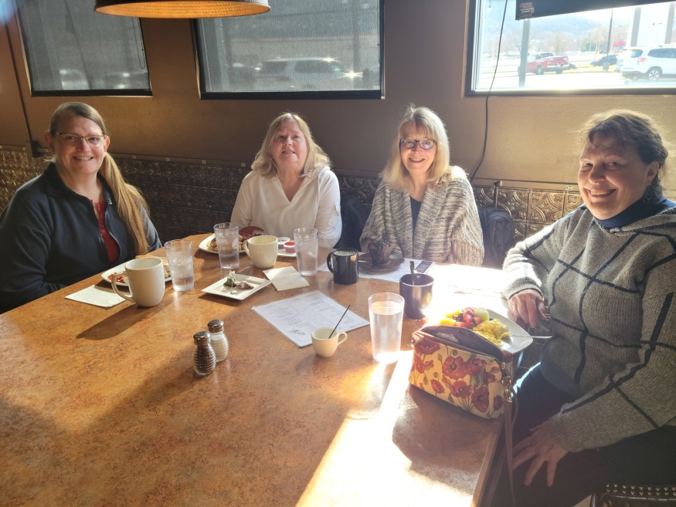

Michele Cook, Carol Nelson-Britten, Kathy Fuss, Barb Albrechtson

* **Pop-Up visit to Saint Rose Convent/Chapel.**

**Mary Ann Gschwind gave an excellent tour. Thank You!**

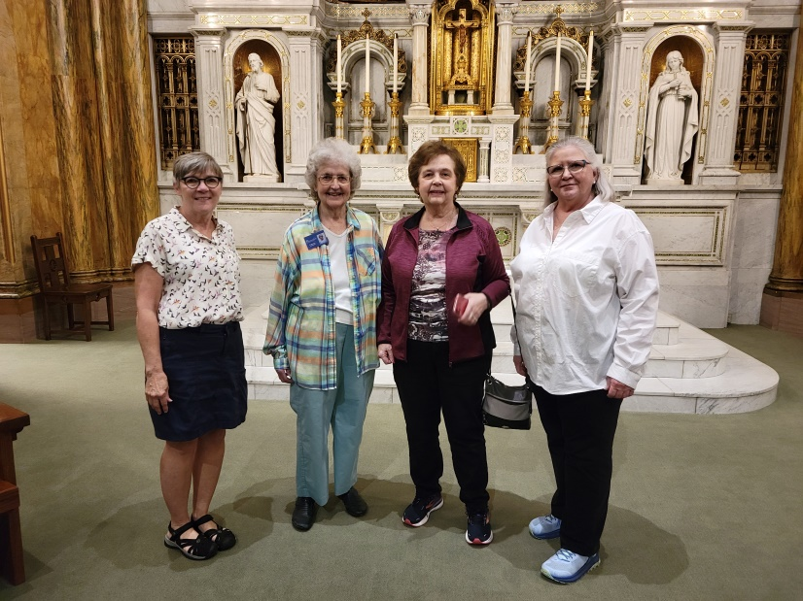

Mary Clark, Mary Ann Gschwind, Carol Egge, Merry Kocar

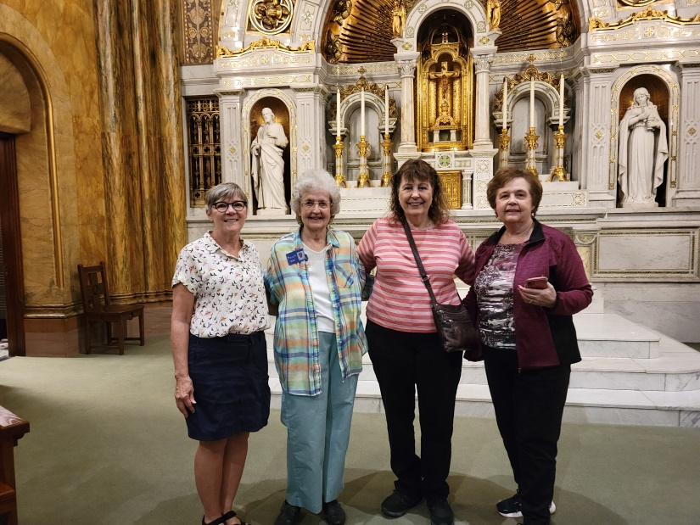

Mary Clark, Mary Ann Gschwind, Barb Albrechtson, Carol Egge

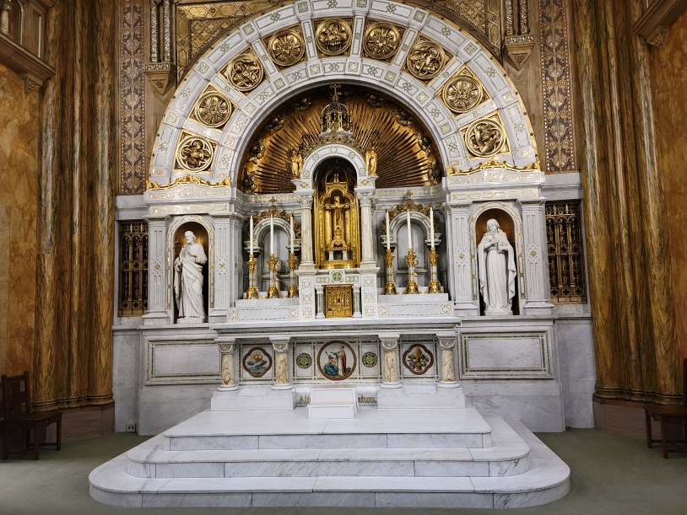

Rose Chapel

* **Please send ideas for programming for 2024-2025 and also ideas of how we can make Alpha Omega better to Barb.**



**Save your books for the Free Library**

**in memory of Claire Jandt**

**At Jandt-Fredrickson Funeral Home and Crematory**

You can bring your books to the fall meeting