**Alpha Omega News**

**November 2021**

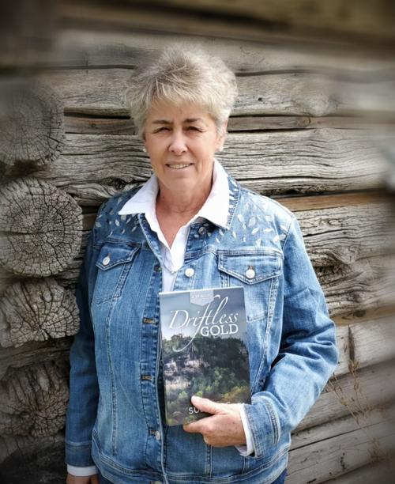

**We had a good turnout for our October18th meeting with Sue Berg presenting**

**on how she became a writer after retiring from teaching 5th-6th grade for Viroqua School District.**

**Her cardinal rule for writing is to write something every day. You cannot fix something if it doesn’t exist. The idea (nugget) for her first book Driftless Gold came from an article from the University Wisconsin La Crosse archives while doing research for her master’s degree “Gold in Them There Hills.” Her second book will be coming out in mid November - Driftless Treasure. (A museum is busted open and the treasures start appearing in La Crosse.) Her stories take place in the driftless area (La Crosse and surrounding areas). She is presently working on her sixth book. It takes about 10-12 months to do the first writing of a book before editing takes place.**

**Committees for 2020-2022**

Communication Representative – Roxanne Fox

Membership – Stephanie Subjek, Terri Daley-Mack

Program – Jackie Meyer, Cyndy Schaper

Scholarship – Connie Albrechtson

Service/Charity Committee – Deb Keller, Priscilla Thibodeau

Fundraising Committee – Joann Zigler, Carol Nelson-Britten



**Jackie Meyer, Mary Wetterling, Louis Sedevie-Lawrynk and Lois Holper have been working diligently on inviting past members to our December 13th meeting. 75 invitations have been sent out in the mail. Hopefully we will have a good turnout of past members.**

**We are still looking for volunteers**

**for being Vice-President**

**Plus we need volunteers for a nomination committee for 2022-2024**

**We will need a new Treasurer for 2022-2024**

**Connie has been treasurer since 2012 and has done a tremendous job for our chapter.**



**Save your books for the Free Library in memory of Claire Jandt**

**At Jandt-Fredrickson Funeral Home and Crematory**

You can drop your books off at

Carol Egge

3647 Bentwood Place

La Crosse, WI 54601

608-788-2173

Or bring to our next meeting



**The Red Folders you have or will be getting needs to be returned by the June meeting.**

**They will be reused for the 2022-2023 year agendas.**

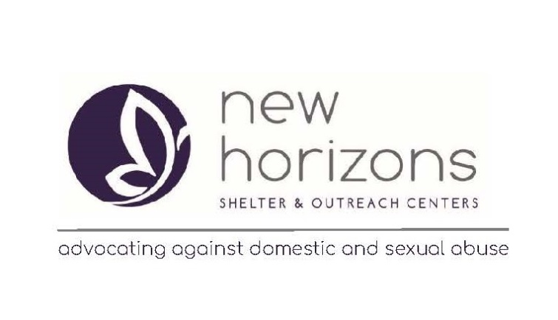

**This is an excerpt from the Thank You letter we received from New Horizon.**

**Dear Delta Kappa Gamma Alpha Omega,**

**You are making a difference in the lives of victims of abuse in our community!**

**Thank you for your generous contribution of $300 to New Horizons.**

**You made hope possible. Your gift is changing lives.**



**A birthday list was created so that we can celebrate each other throughout the year.**

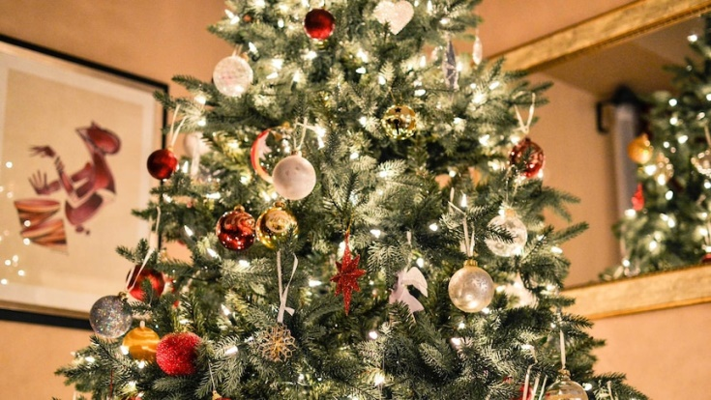

**Our Next meeting will be Monday**

**December 13th**

**Freight House**

**RSV by December 6th to Barb Albrechtson**

**For our teacher scholarship fundraiser**

**We are asking for at least $25 for our teacher scholarship which we give in the spring instead of doing a Chinese Auction**

**If you are not able to attend please send your check to**

**Connie Albrechtson**

**3324 Meadow Lane Pl.**

**La Crosse, Wi 54601**

**We will have a white elephant instead of a Chinese Auction – You do not need to buy anything – Just bring something wrapped that you would like to pass on from your house.**

**We will draw numbers for the order of when you pick your gift. There will be a take away but once an item has been taken three times it is frozen.**