**Alpha Omega News**

**March2023**

**Cindy Stuhr gave a fantastic presentation on how she makes coasters**

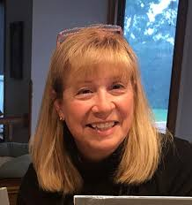

**Here are some coasters she has made in the past.**

# Acrylic Tile Making Class- Cindy Stuhr | River City Gallery

# Upcoming Acrylic Tile Making Class with Cindy Stuhr

Cost: $45.00

**Description**

Instructor: Cindy Stuhr

Class Length: 2.5 hours

Class Cost $30

+Material Cost: $15 Required materials for class includes 8 tiles.

Class Description:

Learn to paint a set of drink coasters using a variety of fluid pour painting styles. You will be guided through 4 different fluid paint pouring techniques to complete a set of coasters.

Class Materials:

8 tile coasters (4 for practice, 4 to make a complete set)

Acrylic paint

Pouring medium

Various supplies including cups, stir sticks, gloves, painting tools, etc.

Important Note: Students will need painting clothes as fluid painting is messy! Also fluid acrylic paint needs 24 hours to dry so coasters can be picked up the next day.

Artist Biography: Cindy Stuhr

I was an elementary educator for 30 years and teaching gave me a creative outlet. Being around children gave me a place to focus my energy and enthusiasm. Once I retired I realized I needed to direct this energy elsewhere and I began to discover my love of abstract art. As a self-taught artist I rely on my appreciation of color and shape to guide the composition of each art piece. My inspiration comes from nature. Each sunset, sunrise and stormy sky offers an ever-changing selection of colors.

My favorite medium to create with is fluid acrylic paint. This painting style gives me the freedom to create without the expectation that my art needs to look a certain way. My art is all about trial and error, learning what works and what doesn’t. I work mainly with fluid acrylic paint and alcohol inks.

Location: River City Gallery, 321 Main Street, La Crosse

Call for questions: 715-379-8611

Top of Form

Attend$45.00

Bottom of Form

**Date & Time**

Sat, Mar 25

1:00 PM - 3:00 PM CST



***Note from Jackie Meyer***

***Words cannot express the feeling in our hearts.***

***Thank you for being with us during this difficult time.***

***Your thoughts, prayers and words of sympathy will always be remembered.***

***Dear DKG Sisters,***

***I truly appreciate all the cards, calls, and visits at the service. The rose is also a beautiful reminder of our friendships.***

***Our family was so blessed with both parents living to age 94!***

***Jackie Meyer***

***In Memory of my dear Mother Eileen Paggi.***



* ***At our February meeting, it was discussed that the delivery of flowers are expensive when going through a florist ($26.38). It was voted on that we would deliver a single rose to anyone who is in the hospital or very sick. We will continue to send a rose to the funeral home for a death of a spouse, child, parent or sibling, if it is in the area. If the funeral is out of the area we will hand deliver the rose to our sister’s home. A list was sent out recently and two roses were and are being delivered already in March.***
* ***At our April meeting we will be taking individual photos of each member so that we can make a membership list with photos so that we get to know each member. We are up to 33 members and it can be difficult to remember everyone’s name. Plus when we are giving to our sister’s who are still teaching and or when we deliver flowers it nice to refresh who we are helping out.***
* ***Be looking soon for signing up for helping out at our***

***May 5-6 Rummage Sale. We will need people to help set up and take down and for hours helping during the sale.***

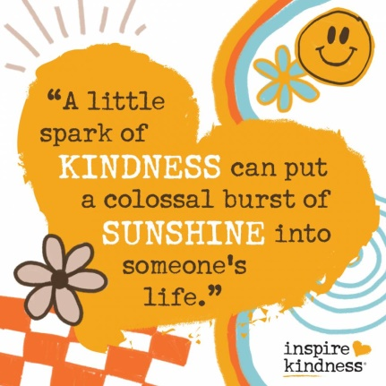

* ***At our June meeting we will be doing a flash kindness event for our sisters of Theta Chapter. Connie Albrechtson and Carol Egge have volunteered to be on the committee. Would love to have others help out with this event. Give me your ideas – cards, notes, tags of kindness sayings with candy or a flower??? Thinking of ways to make our sister chapter feel welcomed at our meeting. Please let me know if you are able to help out with this venture.***
* ***Note cards will be out at the next meeting for suggestions for programs for the 2023-2024 and also to give suggestions on how we can make Alpha Omega a better organization that meets your needs.***



**Our Next Meeting Will Be April 19th**

**Initiation of New Members**

**Annual Dues**

**Dinner at Freight House**

**107 Vine St. – La Crosse**

**4:30 Social**

**5:00 Initiation/Meeting**

**5:45 Dinner**



**Just a Reminder**

**Mentoring Our New Members**

This year we will be mentoring our new members so that they will enjoy being a member of Alpha Omega! We want them to enjoy the fellowship of our group.

This year’s new members are: Cathy Fuchs, Kathy Fuss, Pam Griffith and Shirley Ruoff, Margaret Wood, Mary Ann Gschwind and Amy Hysel

All members are invited to send them a note of appreciation that they are a part of our organization.



**Membership Dues**

**Dues need to be paid by April 30th**

**Dues are $72**

**This may change depending what dues will be for national and state. Will keep you posted if there is a change.**

**Checks should be made out to DKG.**

**Send to Priscilla Thibodeau if you are not attending the April meeting.**

**Priscilla Thibodeau**

**W5850 Cedar Road**

**La Crosse, WI 54601**



***Remember YOU are the center of the reason for DKG!***

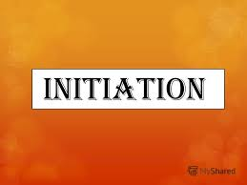

**Remember April is our initiation of new members.**

**Please be thinking of promoting Alpha Omega Chapter to your friends.**

**We just need to open our minds to escape the word “teacher” and think “educator” instead.**

**Consider sharing other professions:**

**Physical therapists,**

**Yoga instructors,**

**Financial experts,**

**Food service directors,**

**Nurses,**

**Doctors,**

**Just think of someone who is**

**A Leader**

**Extremely or crucially important**

**And Prominent**

**Please send information to Barb Albrechtson for any new members to initiate As Soon As Possible.**

**More information is coming about Chapter Member Application.**

**Members can join throughout the year.**

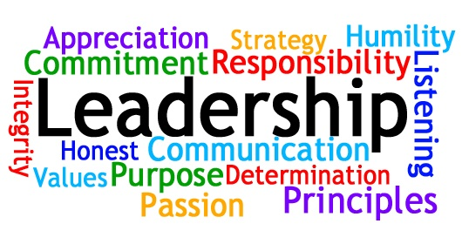

**Officers for 2022-2024**

President – Barb Albrechtson

Vice-President – Kathy Dressler

Treasurer – Priscilla Thibodeau

Corresponding Secretary – Stephanie Baumgartner

Recording Secretary – Jan Marson



**Committees for 2022-2024**

**Communication Representative/Historian** – Roxanne Fox

**Membership** – Stephanie Baumgartner, Terri Daley-Mack,

Kathy Dressler

**Program** – Jackie Meyer, Cyndy Schaper, Marilyn Arndt, Lois Holper, Jan Marson, Shirley Ruoff, Carol Egge, Mary Wetterling

**Scholarship** – Priscilla Thibodeau

**Service/Charity Committee** – Deb Keller, Priscilla Thibodeau,

Lois Holper, Marilyn Arndt, Mary Wetterling

**Fundraising Committee** – Joann Zigler, Mary Wetterling

**By-Laws Committee** – Barb Albrechtson, Kathy Dressler,

Carol Nelson-Britten



**State Conference**

**Saturday May 6, 2023**

**The Ingleside Hotel and Waterpark in Pewaukee**

**DKG L.E.A.D.s; Literacy, Education, Advocacy, Diversity**

**Tentative Schedule**

**8:00 Registration**

**8:30 Welcome & Business Meeting**

**9:00 DKG International Guest Phyllis Hickey, Strategic Outreach Director**

**10:00 Installation of WSO Officers**

**10:50 Breakout Sessions**

**Ghana Library Authority**

**Racine County Underground Railroad Educational Panel (repeated at 1:15)**

**International Speaker Roundtable**

**11:50 Lunch/Missling Achievement Award Presentation**

**12:45 Literary Competition Winner Awards Presentation**

**1:15 Breakout Sessions**

**Literary Competition Reading**

**Among the Hmong**

**Educational Panel (repeat of 10:50)**

**Autism from a Mother’s Perspective**

**2:00 Breakout Sessions**

**European Trip of a Lifetime (Literary Competition)**

**Celebrating Juneteenth Day**

**Funding Opportunities Panel**

**3:00 Celebration of Life and Closing Remarks**

**Come One! Come All!**

**Meet and Share Ideas, Enjoy Friendships,**

**Learn, Improve and Grow!!**

**Registration Information form was in the February WSO State Newsletter – Send form to**

**Kathy Zautner**

**1217 River Park Circle West**

**Mukwonago, WI 53149**

**Cost until April 5th $35**

**After April 5th $40**

**Choice of 3 luncheon menus $35 each**

**Save the Date!**

**International Conference will be in Detroit, Michigan July 11-15**



**Save your books for the Free Library in memory of Claire Jandt**

**At Jandt-Fredrickson Funeral Home and Crematory**

You can

bring your books to the April meeting