**Alpha Omega News**

**December 2021**

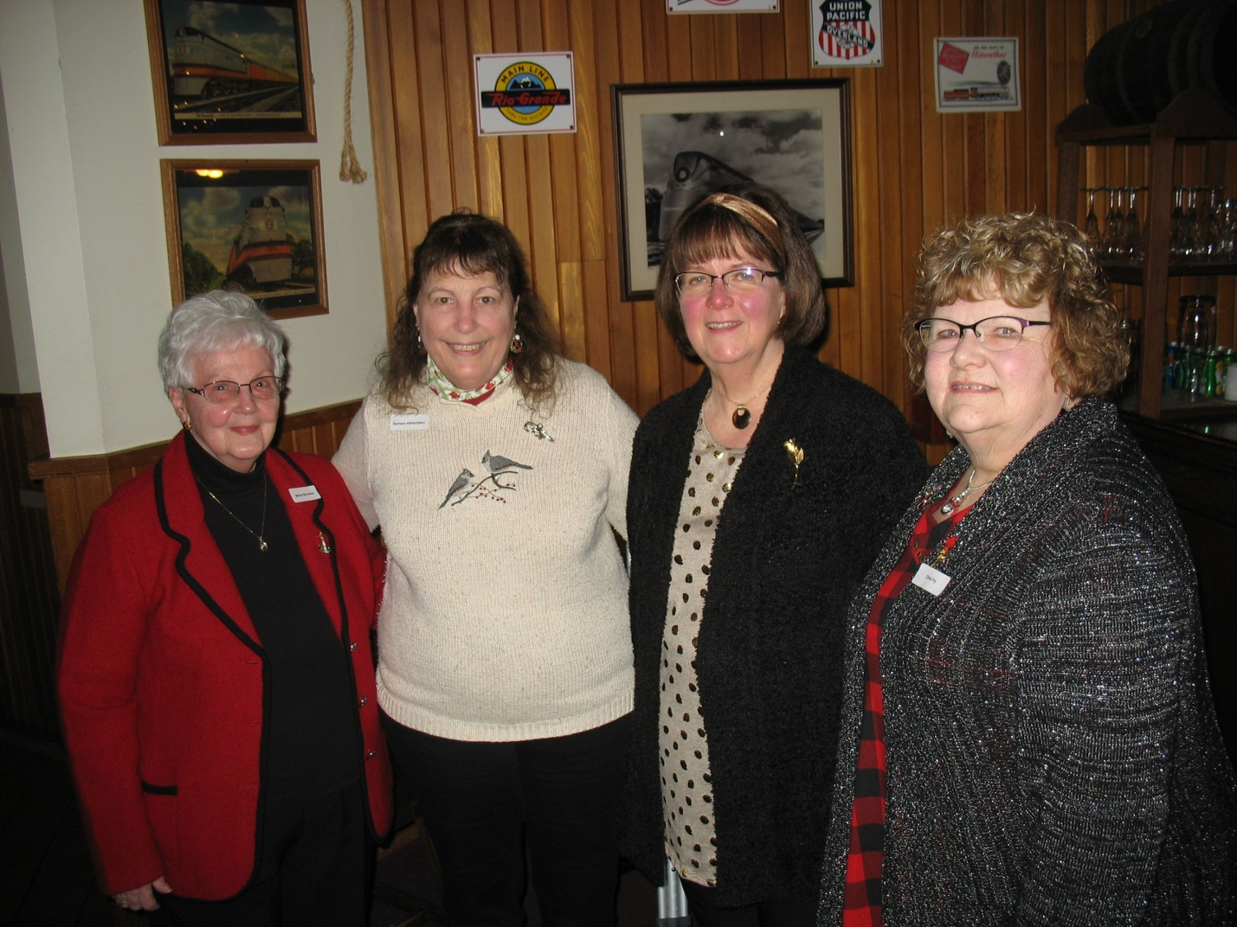

**We had three past members who joined us for our December White Elephant**

**Margaret Wood**

**Kris Fry**

**Marian Michelson**

**We had a wonderful time opening White Elephant gifts and just enjoying being with our fellow sisters**

**and past members.**

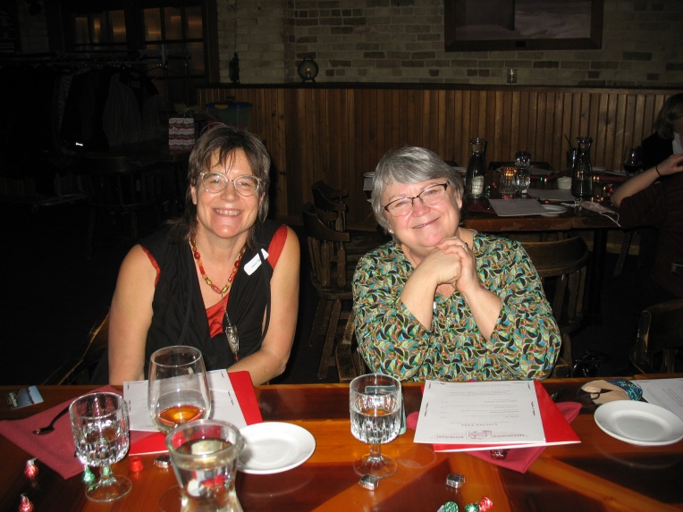

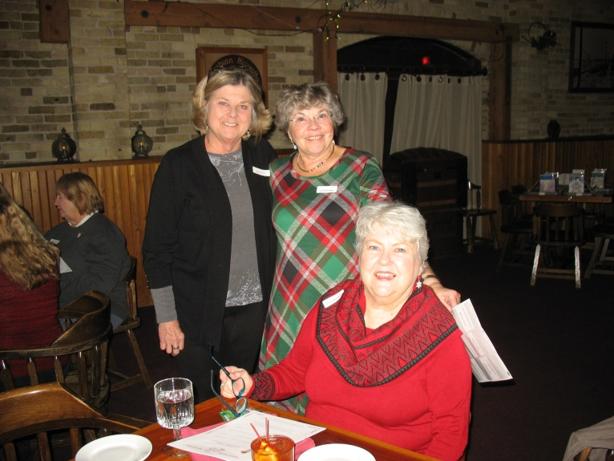

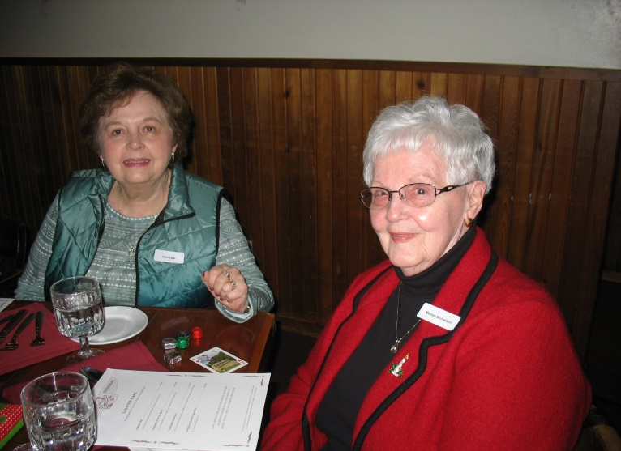

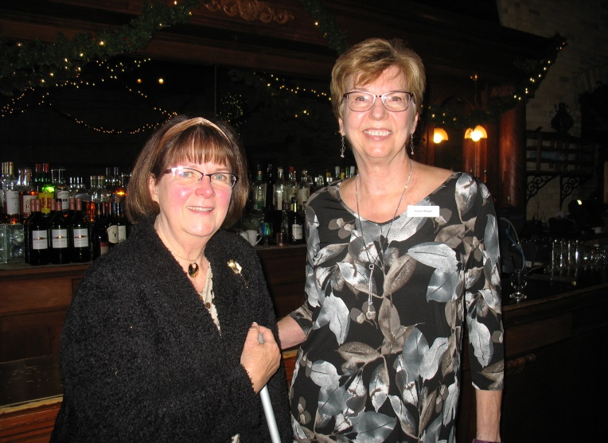

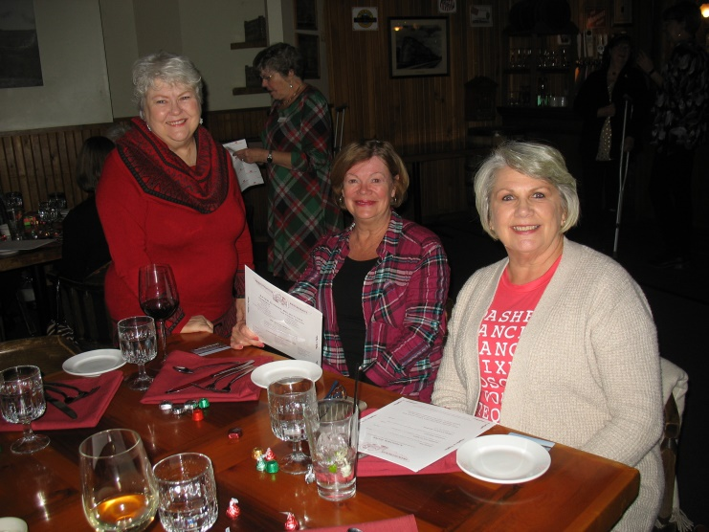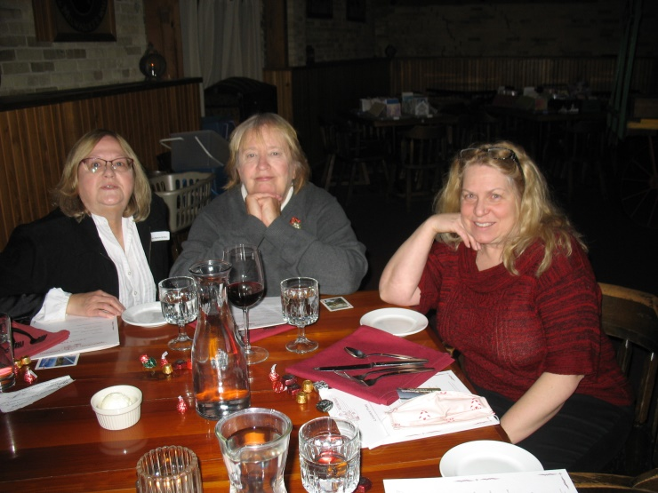

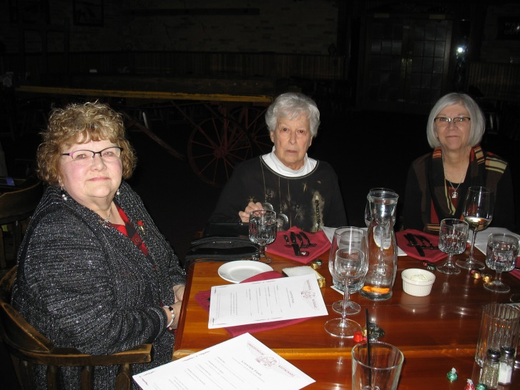

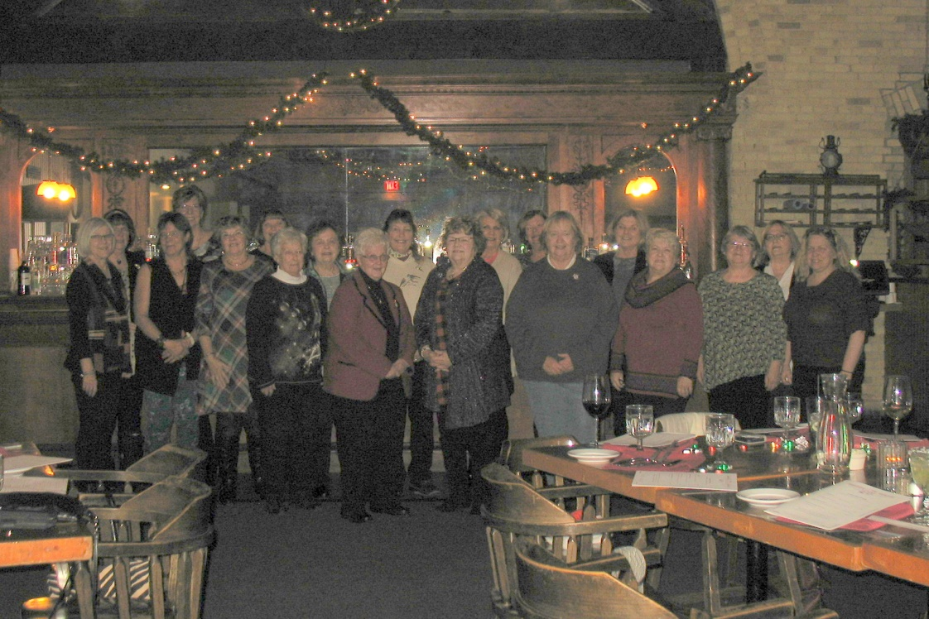

**Trinity Clothes Closet**

**Thanks to the DKG group for over 200 pairs of socks and undies for the Trinity Children’s Clothes Closet. These donations will be distributed to children in the La Crosse seeking essential clothing items.**

**From the Trinity clothes closet.**

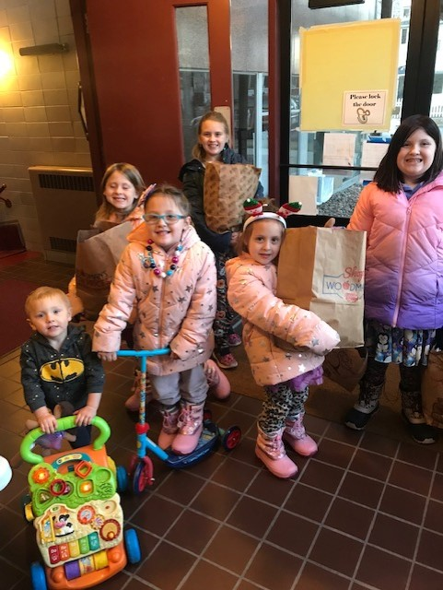

From happy clothes closet customers



**Goes out to Roxanne Fox**

**For developing out Facebook Page**

**Alpha Omega Chapter-DKG-La Crosse, WI**

**Teacher Scholarship**

**We raised so far $545**

**I know that some checks are still coming in for those members who could not attend the meeting.**

**Committees for 2020-2022**

Communication Representative – Roxanne Fox

Membership – Stephanie Subjek, Terri Daley-Mack

Program – Jackie Meyer, Cyndy Schaper

Scholarship – Connie Albrechtson

Service/Charity Committee – Deb Keller, Priscilla Thibodeau

Fundraising Committee – Joann Zigler, Carol Nelson-Britten

Brochure Committee – Carol Nelson-Britten, Cyndy Schaper, and Terri Daley Mack

**Officers**

**We are still looking for volunteers**

**for being Vice-President (Joann Zigler is thinking about possibly doing this)**

**Plus we need volunteers for a nomination committee for 2022-2024**

**Priscilla Thibodeau has volunteered to be Treasurer for 2022-2024**

**Connie has been treasurer since 2012 and has done a tremendous job for our chapter.**



**Save your books for the Free Library in memory of Claire Jandt**

**At Jandt-Fredrickson Funeral Home and Crematory**

Bring to our February Meeting at Tom Sawyer’s Bar & Grill

**Flashback**

**This comes from Jackie Meyer**

**Flashback DKG memory; we have a song.  
We used to sing at our meetings with a few giggles because the tune was hard to follow and finally dropped it. I just read the words again. Very timely today yet**

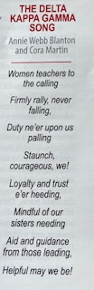

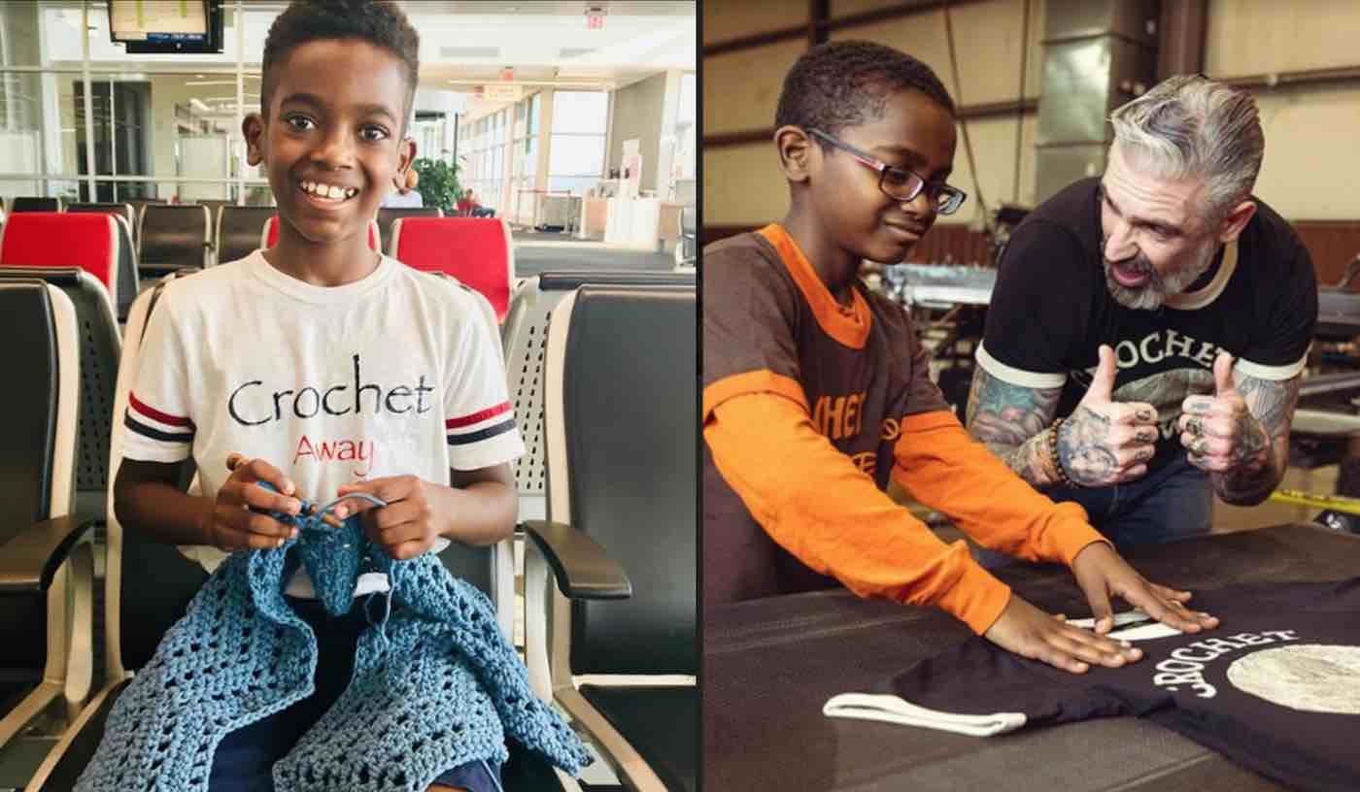

**Our Next meeting will be Tuesday**

**February 15th**

**Tom Sawyer’s Bar & Grill**

**Presentation by Jonah Larson, crochet prodigy**

**RSV by February 8th to Barb Albrechtson**

[**Tzigane2@hotmail.com**](mailto:Tzigane2@hotmail.com)

**Our charity this month is to support Jonah Larson’s latrine project in Ethiopia**



**State Conference**

**Saturday May 7, 2022**

**Fond du Lac at the Radisson**

**Theme: Sharing the DKG Mission, Doing It Together**

**More Information Coming**



**Remember April is our initiation of new members.**

**Please be thinking of promoting Alpha Omega Chapter to your friends.**

**We just need to open our minds to escape the word “teacher” and think “educator” instead.**

**Consider sharing other professions:**

**Physical therapists,**

**Yoga instructors,**

**Financial experts,**

**Food service directors,**

**Nurses,**

**Doctors,**

**Just think of someone who is**

**Key – Leading**

**Extremely or crucially important**

**And Prominent**